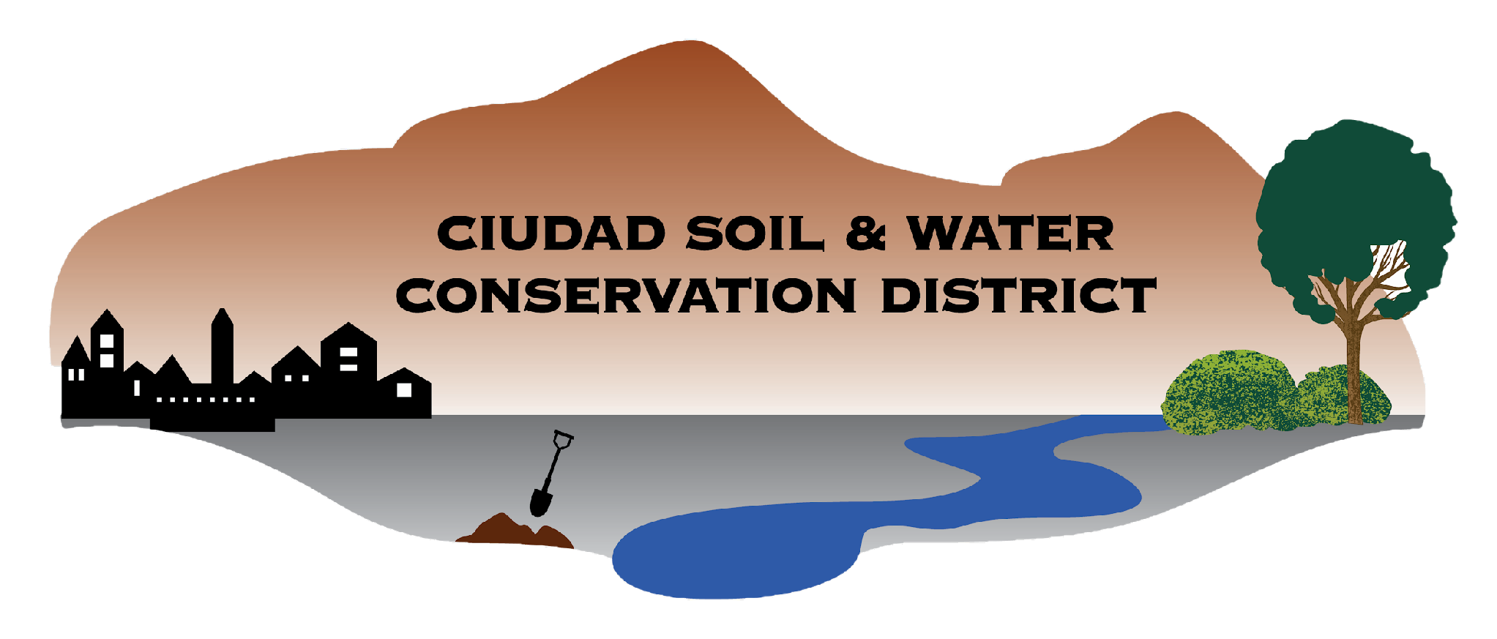

Ciudad Soil and Water Conservation District
100 Sun Ave NE Room 160
Albuquerque, NM 87109
505-510-3478

CIUDAD SOIL AND WATER CONSERVATION DISTRICT
BOARD OF SUPERVISORS MEETING
Zoom
Virtual Meeting

June 15, 2026
Meeting Minutes

- Call to Order 4:31 pm
  - Supervisors present: Attendance confirmed by roll call. A Quorum was present.

Roll call: Steve Glass: Present
Tom Allen: Present
Ramona Goolsby: Present
Maria Young: Present
Gabriella Coughlin: Present
Daniel Conklin: Present
  - Supervisors Absent: Sarah Hurteau
  - Others Present: Tammy Silva, Joshua O'Halloran, Cole Firkins, Katie Mechenbier, Michael Miller, Jared Carbajal, CJ Ames, Alex Ulibarri (left at 4:46), Charlene Pyskoty

- Agenda for 6/15/2026 Review and Approval (Action Item): Tom Allen moved to approve the 6/15/2026 agenda. Seconded by Dan Conklin and approved unanimously by roll-call vote.
Steve Glass: Yes
Tom Allen: Yes
Ramona Goolsby: Yes
Maria Young: Yes
Gabriella Coughlin: Yes
Daniel Conklin: Yes
Sarah Hurteau: Absent

- Review and Approval of Minutes (Action Item)
  - Review and Approval (Action Item): Tom Allen moved to approve the Draft Board Meeting minutes 5.18.2026. Seconded by Dan Conklin and approved by roll-call vote.

Roll Call Vote:
Steve Glass: Yes
Tom Allen: Yes
Ramona Goolsby: Yes
Maria Young: Abstain
Gabriella Coughlin: Yes
Daniel Conklin: Yes
Sarah Hurteau: Absent

- Guest Presentation:
  - Cole Firkins described study on E. Coli in the Middle Rio Grande.

- Public comment: No comments made

- Reports of Partners
  - NMDA (Katie Mechenbier): Steve Glass asked about the NMACD meeting where Ciudad’s submissions recorded on the points sheet were not submitted or submitted late. Ramona Goolsby requested Katie describe the worksheet for new board supervisors and staff. A written report was provided. Katie M. reviewed the report with the board.
  - NRCS (Jill Mumford): No report was provided.
  - Other: N/A

- Consent Agenda
  - FY27 NMC Aware and Prepare Grant Resolution.

  - Wildland Seed Harvesting grant MOA

Tom Allen made a motion to approve the consent agenda. Seconded by Maria Young and approved by roll call vote.
Roll Call Vote:
Steve Glass: Yes
Tom Allen: Yes
Ramona Goolsby: Yes
Maria Young: Yes
Gabriella Coughlin: Yes
Daniel Conklin: Yes
Sarah Hurteau: Absent

- Action Items
  - Approval of the Ciudad FY 27 Action Plan. Brief discussion of the ambitious, comprehensive nature of the plan. Dan Conklin made a motion to approve the FY27 Action Plan. Seconded by Tom Allen and approved by roll call vote.

Roll Call Vote:
Steve Glass: Yes
Tom Allen: Yes
Ramona Goolsby: Yes
Maria Young: Yes
Gabriella Coughlin: Yes
Daniel Conklin: Yes
Sarah Hurteau: Absent

- Finance Committee (Action Items):
  - Finance Committee Report. The report was verbally reviewed by Tammy Silva. Dan Conklin recommended that the board accept the report and made a motion to approve the report. Seconded by Tom Allen and approved by roll call vote.

Roll Call Vote:
Steve Glass: Yes
Tom Allen: Yes
Ramona Goolsby: Yes
Maria Young: Yes
Gabriella Coughlin: Yes
Daniel Conklin: Yes
Sarah Hurteau: Absent

  - Budget Adjustment Request: 319 MRG WPB; Resolution. The BAR and accompanying resolution were reviewed by Tammy Silva. Tom Allen moved to adopt the resolution. Seconded by Maria Young and approved by roll call vote.

Roll Call Vote:
Steve Glass: Yes
Tom Allen: Yes
Ramona Goolsby: Yes
Maria Young: Yes
Gabriella Coughlin: Yes
Daniel Conklin: Yes
Sarah Hurteau: Absent

  - FY2028-2032 ICIP resolution; folder. The ICIP contents and accompanying resolution were reviewed by Joshua O’Halloran. Tom Allen moved to authorize Steve Glass’s signature on the resolution. Seconded by Dan Conklin and approved by roll call vote.

Roll Call Vote:
Steve Glass: Yes
Tom Allen: Yes
Ramona Goolsby: Yes
Maria Young: Yes
Gabriella Coughlin: Yes
Daniel Conklin: Yes
Sarah Hurteau: Absent

- Reports of committees and possible Action Items
  - Policy Committee: Compliance and Transparency. Ramona Goolsby brought up the record of board agendas and minutes on our website, many of which are labeled as drafts. Ramona and Steve Glass described the difficulties in accessing some of those documents and Steve described how to fix the access issue they found.
  - Personnel Committee: Joshua O’Halloran described new hires.
  - Mill Levy Committee: No report.
  - Government Affairs Committee: Possible District comment on WQCC Surface Waters Permitting Rule (SG comments here). Tom Allen moves to approve the sending of the example letter, with addition of language about funding and working with SWCDs. Seconded by Maria Young and approved by roll call vote.

Roll Call Vote:
Steve Glass: Yes
Tom Allen: Yes
Ramona Goolsby: Yes
Maria Young: Yes
Gabriella Coughlin: Yes
Daniel Conklin: Yes
Sarah Hurteau: Absent

- District Staff Report
  - Staff Report. CJ Ames gave a report about the Agriculture Program
  - FY26 Point System Worksheet. Joshua O’Halloran reviewed the worksheet.

- Other Business
  - District Map Drafts - Does the board have feedback for these drafted maps or ideas for other maps that we need. Steve Glass suggested additional boundaries identified: counties, Tribal lands, etc.
  - Logo design - Discussion of use of new logo for hats, shirts, tabling materials.

Adjourned 6:36 PM

Submitted by: CJ Ames
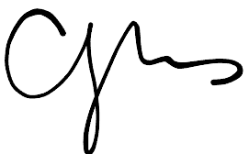
Validated by:

Date approved:

