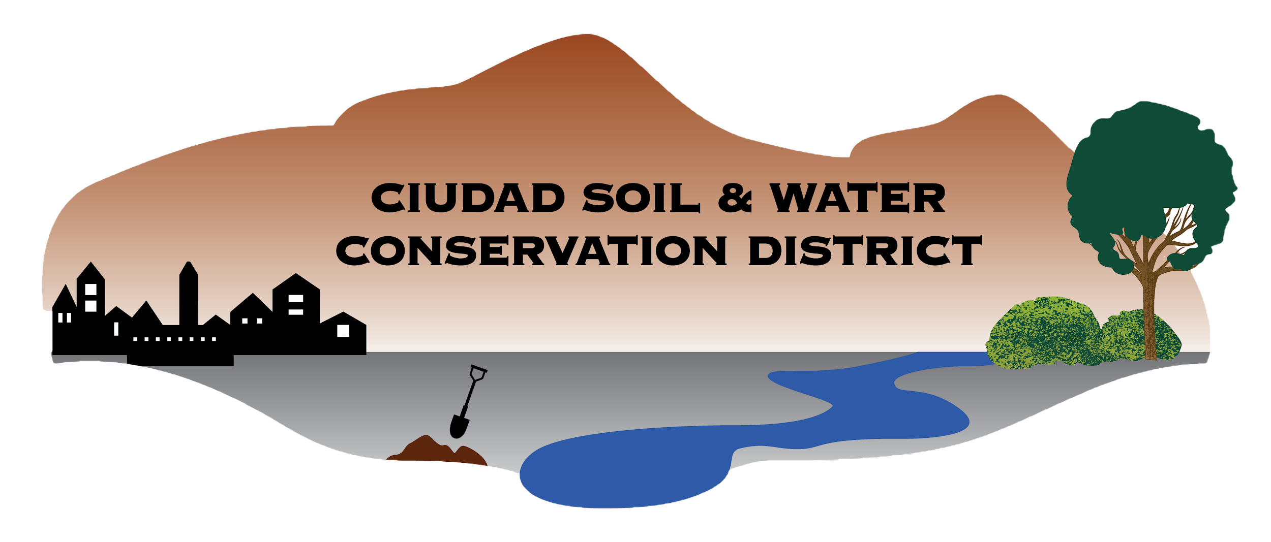

Ciudad Soil and Water Conservation District
100 Sun Ave NE Room 160
Albuquerque, NM 87109
505-510-3478

CIUDAD SOIL AND WATER CONSERVATION DISTRICT
BOARD OF SUPERVISORS MEETING
Zoom
Virtual Meeting

April 27, 2026
DRAFT
Meeting Minutes

- Call to Order 4:34 pm
  - Supervisors present: Attendance confirmed by roll call. A Quorum was present.

Roll call: Steve Glass: Present
Tom Allen: Present
Ramona Goolsby: Present
Maria Young: Present
Gabriella Coughlin: Absent
Daniel Conklin: Present (arrived 4:46, left at 6:12))
Sarah Hurteau: Present

  - Supervisors Absent:
  - Others Present: Jennifer Martinez (left @ 5:19), John Wright (left @5:19), Erin Blaz, Janella Cruz, Michael, Tammy Silva, Allie Arning, Joshua O'Halloran (arrived 5:38)

- Agenda for 4/27/2026 Review and Approval (Action Item): Tom Allen moved to approve the 4/27/2026 agenda. Seconded by Maria Young and approved unanimously by roll-call vote.
Steve Glass: Yes
Tom Allen: Yes
Ramonda Goolsby: Yes
Maria Young: Yes
Gabriella Coughlin: Absent
Daniel Conklin: Not Present
Sarah Hurteau: Yes

- Review and Approval of Minutes (Action Item)
  - Review and Approval (Action Item): Tom Allen moved to approve the Draft Board Meeting minutes 3.16.26. Seconded by Sarah Hurteau and approved by roll-call vote.

Roll Call Vote:
Steve Glass: Yes
Tom Allen: Yes
Ramonda Goolsby:
Maria Young: Yes
Gabriella Coughlin: Absent
Daniel Conklin: Not Present
Sarah Hurteau: Yes

- Guest Presentation: John Wright, NM2050
  - NM2025 is a non-profit organization that supports a garden and nutrition/culinary arts internship program at Rio Grande High School and is currently partnering with Sandia High School and Valley High School to explore expansion. Students receive credits for the internship program. Jennifer Martinez is the internship coordinator and helps students get career mentoring paired with a farm to table curriculum offered by teachers. John Wright is requesting $37,000 in financial support to expand the program to Sandia and Valley High School. Current funding sources include “Education at Work, BernCo Open Space, APS, Commissioner Baca, Outdoor Equity Fund, NM2050.”

- Public comment: No comments made

- Reports of Partners
  - NMDA (Katie Mechenbier): A written report was provided.
  - NRCS (Janelle Cruz): A written and verbal report was provided by Janella Cruz. Jason Martin is now acting State Soil Scientist. NRCS is looking for contract engineers and support from Ciudad SWCD through a cooperative agreement.
  - Other:

- Action Items
  - MOU with MRGCD.This resembles umbrella agreements with Bernalillo County and allows the two agencies to work together and achieve goals that are in alignment and pertinent to each individual agency. Sarah Hurteau made a motion to approve Steve Glass’s signature on the MOU on behalf of the board. Seconded by Tom Allen and approved by roll call vote.

Roll Call Vote:
Steve Glass: Yes
Tom Allen: Yes
Ramonda Goolsby: Yes
Maria Young: Yes
Gabriella Coughlin: Absent
Daniel Conklin: Yes
Sarah Hurteau: Yes

  - Office Space Lease. Sarah Hurteau made a motion to approve Steve Glass’s signature on the lease. Seconded by Tom Allen and approved by roll call vote.

Roll Call Vote: Steve Glass: Yes
Tom Allen: Yes
Ramonda Goolsby: Yes
Maria Young: Yes
Gabriella Coughlin: Absent
Daniel Conklin: Yes
Sarah Hurteau: Yes

  - Watershed Based Plan MOA with NMED. NMED is able to directly contract with Ciudad SWCD for this project. The agreement is standard and will be signed by the District Manager. Dan Conklin made a motion to approve Joshua O’Halloran’s signature on the MOA on behalf of the District. Seconded by Tom Allen and approved by roll call vote.

Roll Call Vote: Steve Glass: Yes
Tom Allen: Yes
Ramonda Goolsby: Yes
Maria Young: Yes
Gabriella Coughlin: Absent
Daniel Conklin: Yes
Sarah Hurteau: Yes

  - Contract with Tetra Tech for MRG WBP. Ciudad SWCD can contract directly with Tetra Tech through the statewide price agreement to implement the NMED funding for the watershed based plan. Chairman Glass made a suggestion that the District Manager sign the contract since he is the signatory on the NMED agreement. Sarah Hurteau noted the agreement assigns all project documents as property of Tetra Tech, Chairman Glass crossed this statement on the contract for Tetra Tech’s review. Tom Allen made a motion to approve Joshua O’Halloran’s signature on the contract. Seconded by Sarah Hurteau and approved by roll call vote.

Roll Call Vote: Steve Glass: Yes
Tom Allen: Yes
Ramonda Goolsby: Yes
Maria Young: Yes
Gabriella Coughlin: Absent
Daniel Conklin: Yes
Sarah Hurteau: Yes

  - IT Contract with myITsupport LLC. Ciudad SWCD currently has no IT support contractor. This was brought to the board because it is a new expense as it was not in the FY26 budget. Sarah Hurteau made a motion to approve Steve Glass’s signature on the contract. Seconded by Tom Allen and approved by roll call vote.

Roll Call Vote: Steve Glass: Yes
Tom Allen: Yes
Ramonda Goolsby: Yes
Maria Young: Yes
Gabriella Coughlin: Absent
Daniel Conklin: Yes
Sarah Hurteau: Yes
  - HR contract with Edwards HR Consulting LLC. The contract is based on our staff size, provides support with reviewing and implementing the employee handbook, manager training, etc and anticipates a few hours a month of support. Sarah Hurteau made a motion to approve Joshua O’Halloran’s signature on the contract on behalf of the District. Seconded by Tom Allen and approved by roll call vote.

Roll Call Vote: Steve Glass: Yes
Tom Allen: Yes
Ramonda Goolsby: Yes
Maria Young: Yes
Gabriella Coughlin: Absent
Daniel Conklin: Yes
Sarah Hurteau: Yes

  - Marketing/event planning contract with Semilla Strategies. Strategic communications, messaging, event planning, social media planning and delivery. Tom Allen made a motion to approve Joshua O’Halloran’s signature on the contract on behalf of the District. Seconded by Sarah Hurteau and approved by roll call vote.

Roll Call Vote: Steve Glass: Yes
Tom Allen: Yes
Ramonda Goolsby: Yes
Maria Young: Yes
Gabriella Coughlin: Absent
Daniel Conklin: Absent
Sarah Hurteau: Yes

  - PSA with APS. APS is hiring Ciudad SWCD to support irrigation installation and professional development for teachers to maintain the system at Polk MS. This is a pass-through of funds, with an administrative fee. The insurance requirement is beyond Ciudad’s state coverage and the Agriculture Manager will confirm the insurance requirement. Sarah Hurteau made a motion to approve Steve Glass’s signature on the contract pending the resolution of the insurance requirement. Seconded by Tom Allen and approved by roll call vote.

Roll Call Vote: Steve Glass: Yes
Tom Allen: Yes
Ramonda Goolsby: Yes
Maria Young: Yes
Gabriella Coughlin: Absent
Daniel Conklin: Absent
Sarah Hurteau: Yes

  - Updated Work Plan for WUI 3927. There is a new signature request from Ciudad because the state’s signatory changed from the Cabinet Secretary to the State Forester. Sarah Hurteau made a motion to approve Steve Glass’s signature on the contract pending the resolution of the insurance requirement. Seconded by Tom Allen and approved by roll call vote.

Roll Call Vote: Steve Glass: Yes
Tom Allen: Yes
Ramonda Goolsby: Yes
Maria Young: Yes
Gabriella Coughlin: Absent
Daniel Conklin: Absent
Sarah Hurteau: Yes

  - Mill levy rate resolution. The board and staff worked together on a budget for the .25 mill levy rate. There was a transcription error in the original budget projection, and the budget has been adjusted to reflect the most agreed-upon projection. Sarah Hurteau made a motion to approve the Mill Levy Resolution and Steve Glass’s signature on the resolution for submission to the Soil and Water Conservation Commision. Seconded by Tom Allen and approved by roll call vote.

Roll Call Vote: Steve Glass: Yes
Tom Allen: Yes
Ramonda Goolsby: Yes
Maria Young: Yes
Gabriella Coughlin: Absent
Daniel Conklin: Absent
Sarah Hurteau: Yes

  - PSA with Lopez Precision. Water Resources Research Institute funding for an irrigation project. Ciudad was able to use MRGCDs RFP to source one of their on-call contractors (allowable because MRGCD stipulated that other government agencies are able to utilize their on-call contractors). Sarah Hurteau made a motion to approve Steve Glass’s signature on the PSA. Seconded by Tom Allen and approved by roll call vote.
Roll Call Vote: Steve Glass: Yes
Tom Allen: Yes
Ramonda Goolsby: Yes
Maria Young: Yes
Gabriella Coughlin: Absent
Daniel Conklin: Absent
Sarah Hurteau: Yes

  - Watershed Small Grant RFA. Chairman Glass expressed uncertainty if this action item is necessary since it is included in the draft FY27 budget. This is on the agenda because staff would like to post the RFA before the next fiscal year begins to start the process. Tom Allen moved to vacate the action item as it is not necessary for the board to approve the posting of RFA or the language of the RFA and the expenditure of the funds are contingent on the approval of the FY27 budget. Seconded by Ramona Goolsby and approved by roll call vote.

Roll Call Vote: Steve Glass: Yes
Tom Allen: Yes
Ramonda Goolsby: Yes
Maria Young: Yes
Gabriella Coughlin: Absent
Daniel Conklin: Absent
Sarah Hurteau: Abstain

- Finance Committee (Action Item):
  - Finance Committee Report. The report was verbally reviewed by Tammy Silva. Tom Allen recommended that the board accept the report, then moved for acceptance. Seconded by Sarah Hurteau and approved by roll call vote.

Roll Call Vote:

Steve Glass: Yes
Tom Allen: Yes
Ramonda Goolsby: Yes
Maria Young: Yes
Gabriella Coughlin: Absent
Daniel Conklin: Absent
Sarah Hurteau: Yes

  - Approval of Budget Adjustment Request (BAR). This is a budget resolution that presents any grants or additional revenue Ciudad received after the FY26 budget was set to ensure that we are not expending funds beyond our revenue set with DFA. Tom Allen made a motion to approve the BAR and approve Steve Glass’s signature on behalf of the board. Seconded by Sarah Hurteau and approved by roll call vote.

Roll Call Vote:
Steve Glass: Yes
Tom Allen: Yes
Ramonda Goolsby: Yes
Maria Young: Yes
Gabriella Coughlin: Absent
Daniel Conklin: Absent
Sarah Hurteau: Yes

- Reports of committees and possible Action Items
  - Policy Committee: No reports to share
  - Personnel Committee: Chairman Glass provided updates on staffing changes.
  - Mill Levy Committee: Parcel lists are in process by both Sandoval County and Bernalillo County.
  - Government Affairs Committee: No reports to share

- District Staff Report.

- Other Business
  - Next month the Board will have appointed supervisors on the agenda.
  - Chairman Glass suggested a consensus agenda for future meetings.

Adjourned 7:18 PM

Submitted by: Erin Blaz
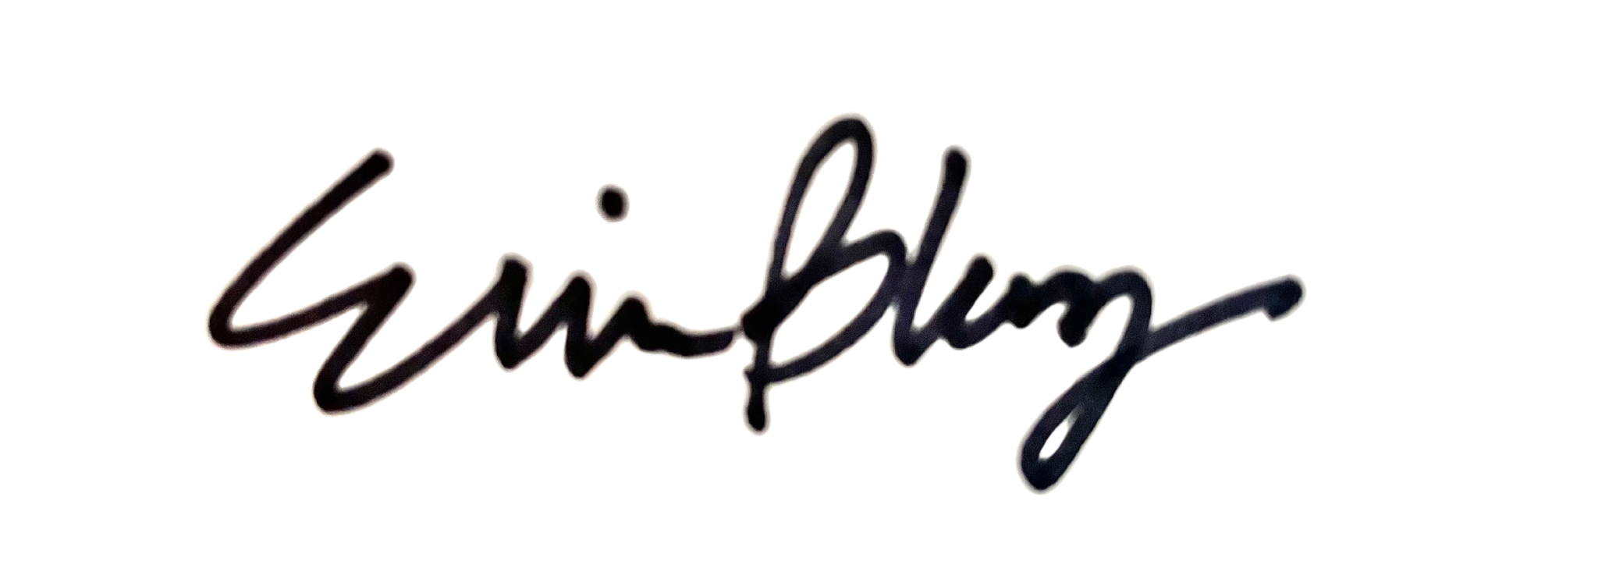

Validated by:

Date approved:

